**DAILY ONLINE ACTIVITIES SUMMARY**

|  |  |  |  |  |  |  |  |
| --- | --- | --- | --- | --- | --- | --- | --- |
| **Date:** | 08-07-2020 | | | | **Name:** | Gudugunti Anirudh | |
| **Sem & Sec** | IV A sec | | | | **USN:** | 4AL18CS023 | |
| **Online Test Summary** | | | | | | | |
| **Subject** | | Design and Analysis of Algorithms | | | | | |
| **Time limit** | | 1hr | | **Score** | | -- | |
| **Certification Course Summary** | | | | | | | |
| **Course** | C programming | | | | | | |
| **Certificate Provider** | | | Udemy | **Duration** | | | **11.5hr** |
| **Coding Challenges** | | | | | | | |
| **Problem Statement:**  1: Given the participants' score sheet for your University Sports Day, you are required to find the runner-up score. You are given scores. Store them in a list and find the score of the runner-up. | | | | | | | |
| **Status:** completed | | | | | | | |
| **Uploaded the report in Github** | | | | yes | | | |
| **If yes Repository name** | | | | https://github.com/alvas-education-foundation/anirudh_gudugunti/tree/master/daily_progress | | | |
| **Uploaded the report in slack** | | | | yes | | | |

**Online Test Details:** The test was from module 1 of DAA. There were 3 questions given to us to write within 45 minutes. We had to scan the answers that we have written in A4 sheets and make it as a pdf and submit it in Google classroom.

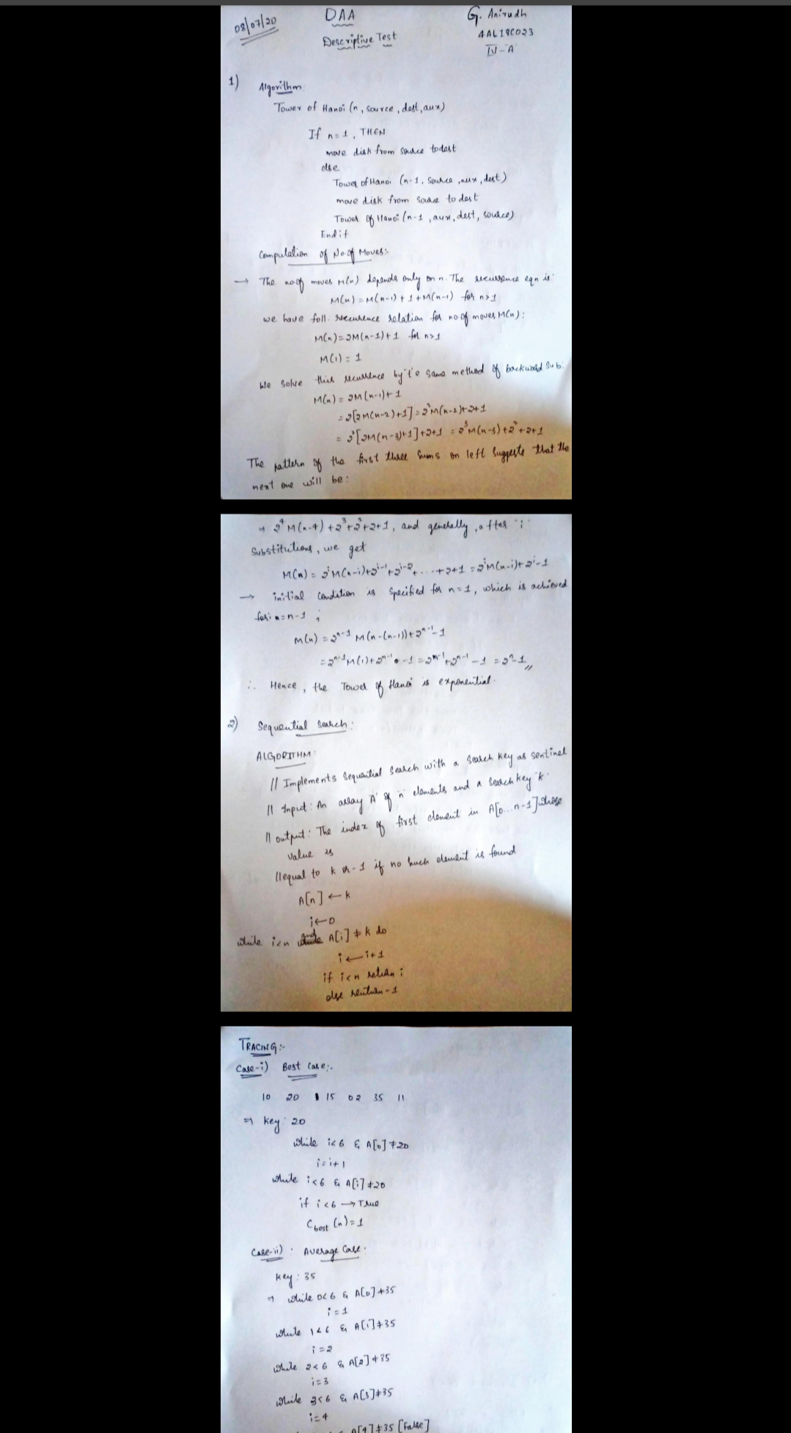

Snapshot of certification course:

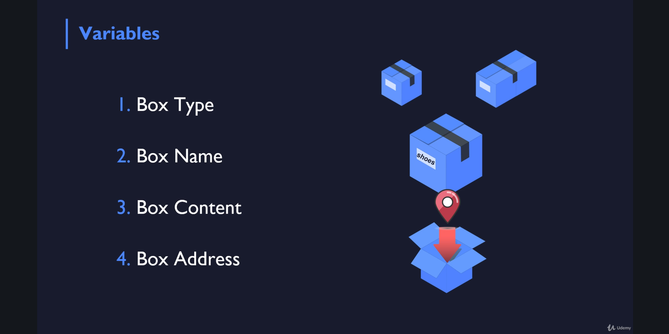

**Types of variables:**

**1.Box type**

**2. Box name**

**3. Box content**

**4. Box address**

**Online coding:**

Problem 1: (using Python) Given the participants' score sheet for your University Sports Day, you are required to find the runner-up score. You are given scores. Store them in a list and find the score of the runner-up.

